TM
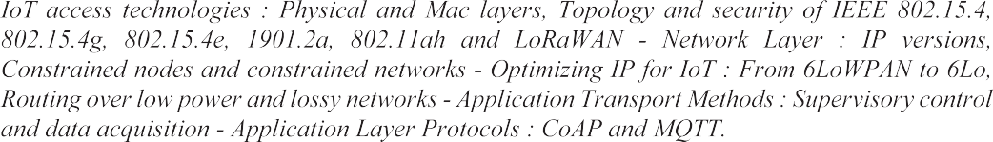

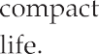
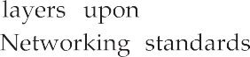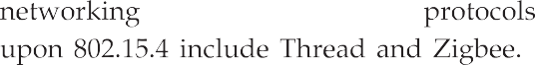

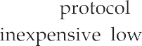

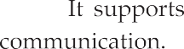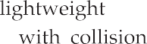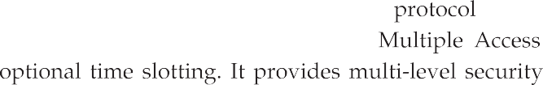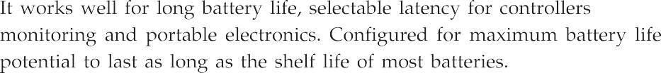

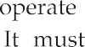
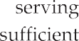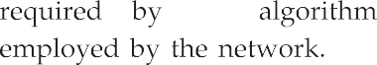

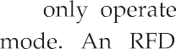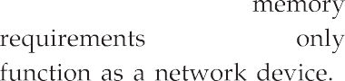Full function device Reduced function device Communication flow

PAN
coordinator

PAN
coordinator
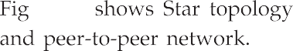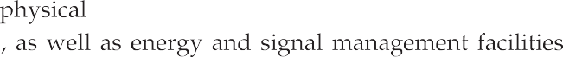

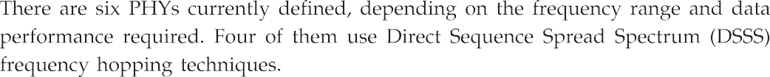
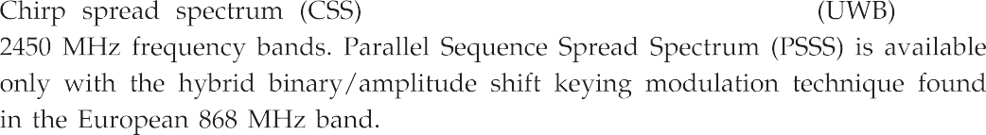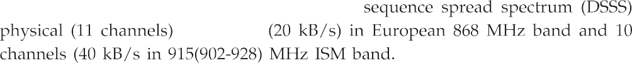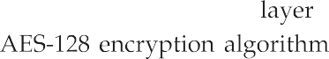

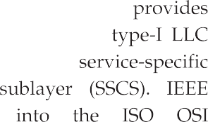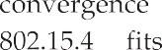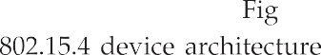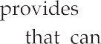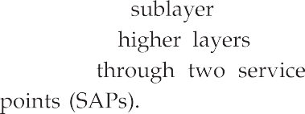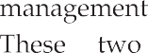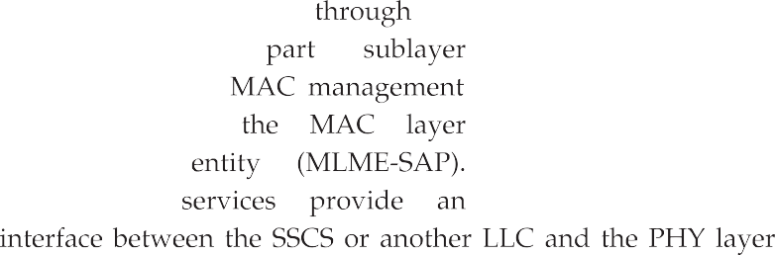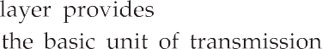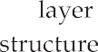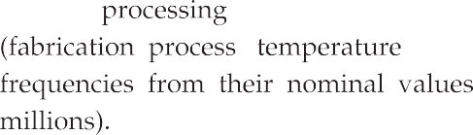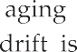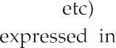
Upper layers
802.2 LLC
SSCS
MAC
PHY
Physical medium

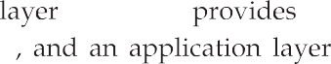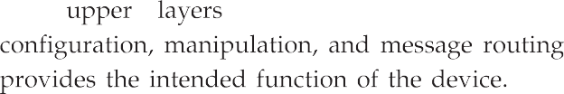

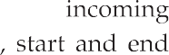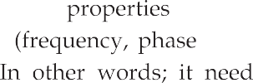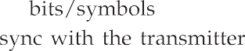

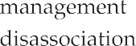

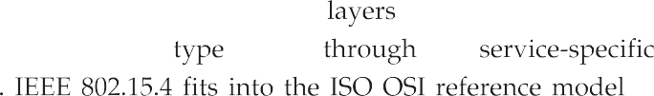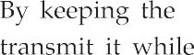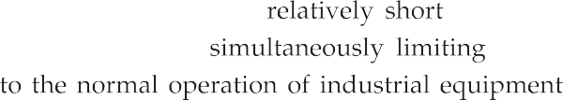

Bytes : 2 1 0-20 Variable 2

PHY
Frame Sequence Address
control number
info
Payload
Frame check sequence
MAC
sublayer
MAC header (MHR)
MAC service data MAC footer
unit (MSDU)
(MFR)
MAC protocol data unit (MPDU)
Synchronization PHY
header
header
PHY service data unit (PSDU)
PHY protocol data unit (PPDU)
layer

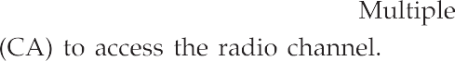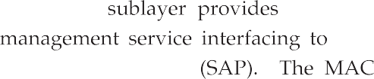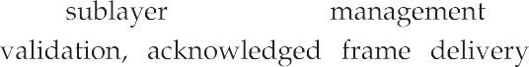

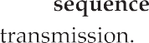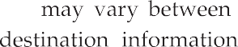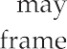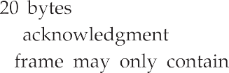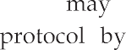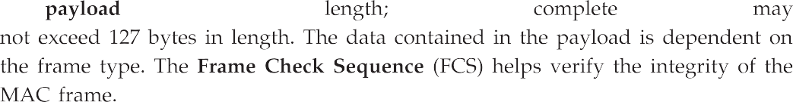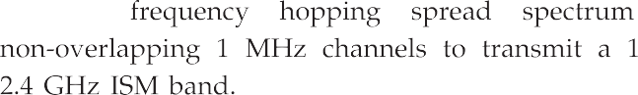

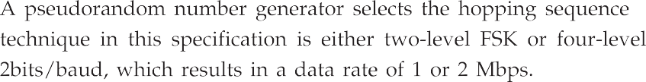
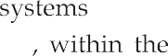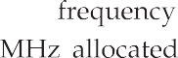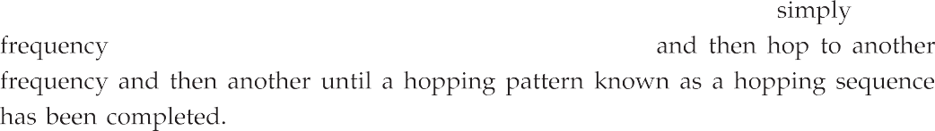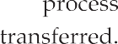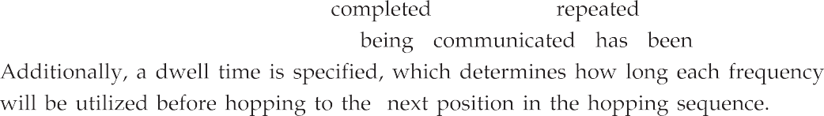

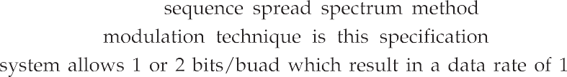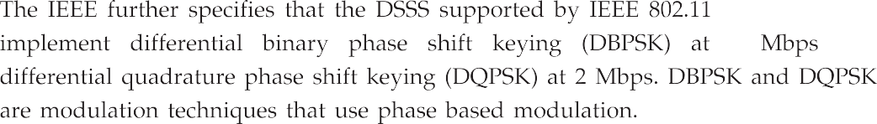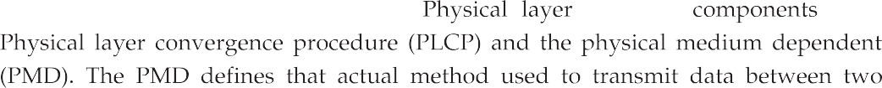

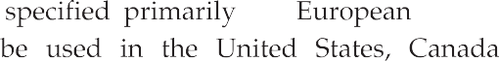
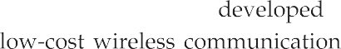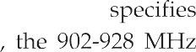

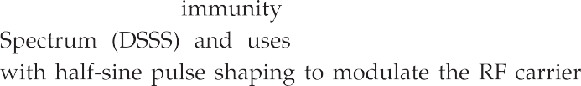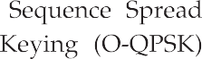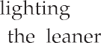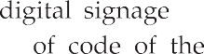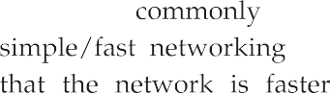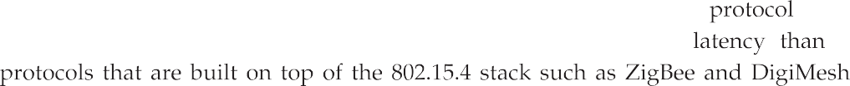

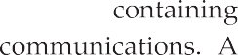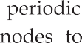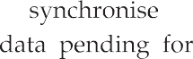Contention Access Period (CAP)
Beacon
Beacon

Time

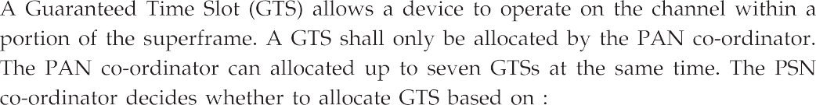

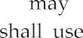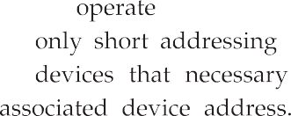Contention Access Period (CAP)
…
…
Beacon

Contention Free Period (CFP)
GTSn
GTS1
Beacon

Time
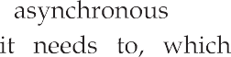

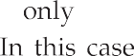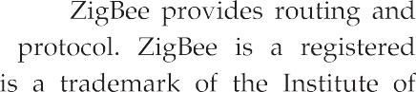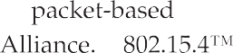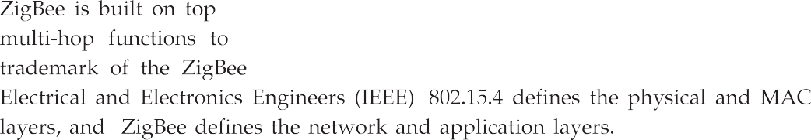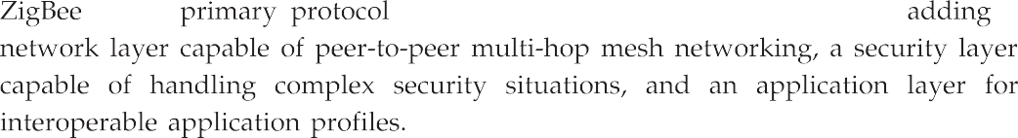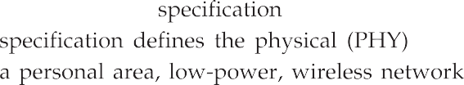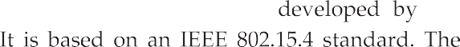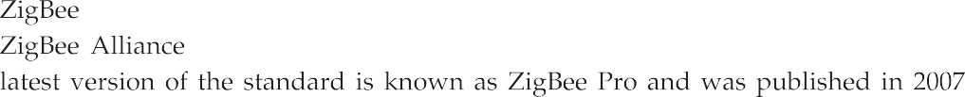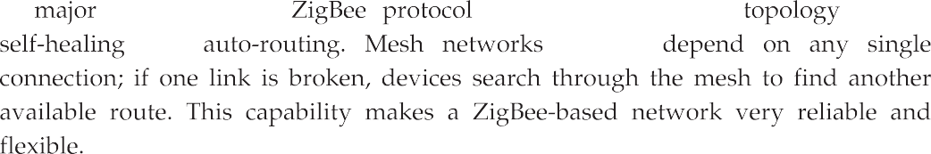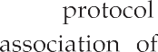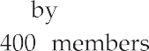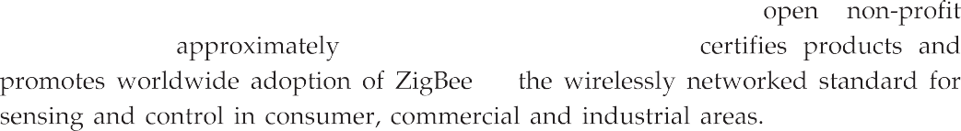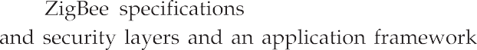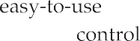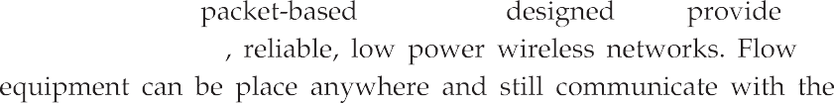

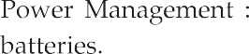
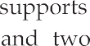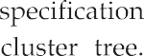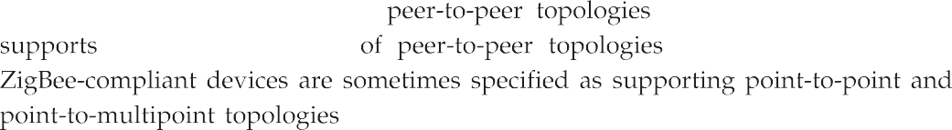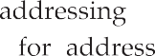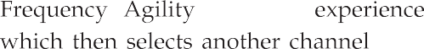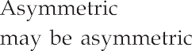

Zigbee
Application layer
Customer application
Application profile
Zigbee
MAC layer
IEEE 802.15.4
PHY layer
Application
Applications
Profile
Appli support
Network
Zigbee network
SSCS
Link
MAC
Physical
868/915
2450
Application framework
Network layer

IEEE 802.15.4

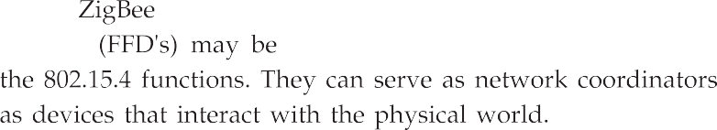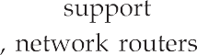
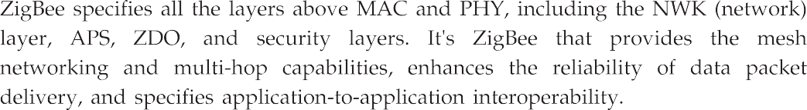
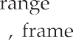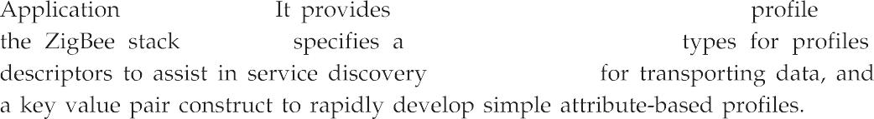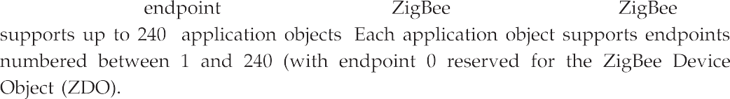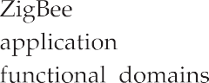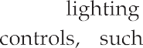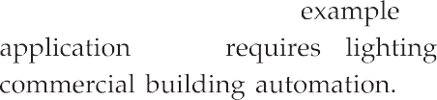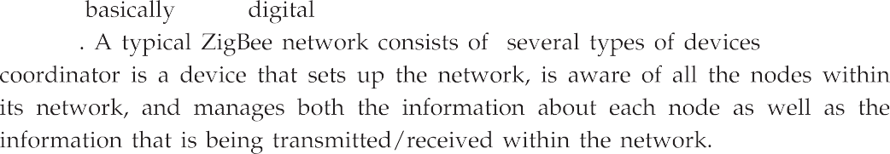

Requests for manipulates the data
Binding
Client
Server
Has the source data

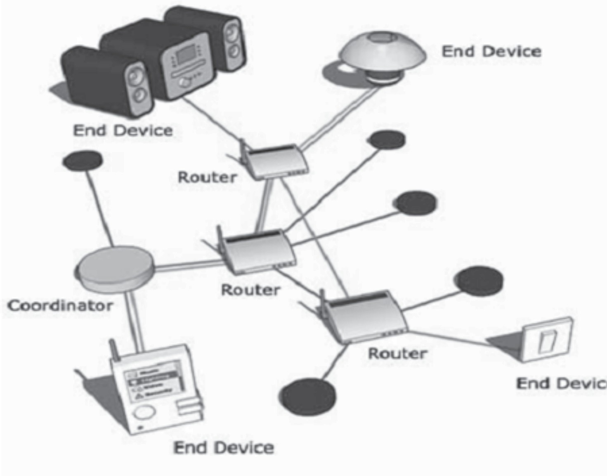In the output cluster list
End device
End device
Router
Coordinator
Router
Router
End device
End device
In the input cluster list

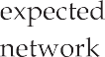
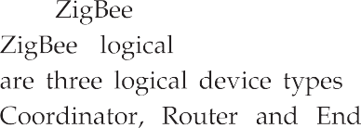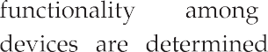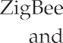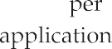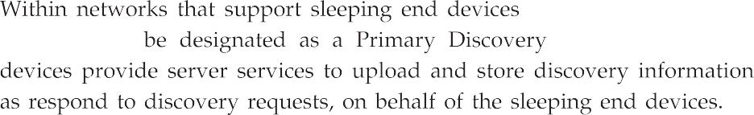

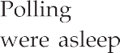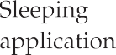

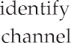
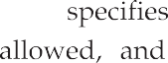

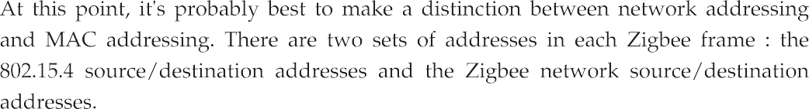
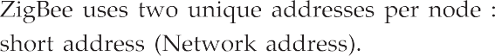
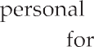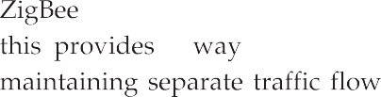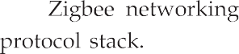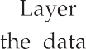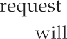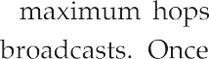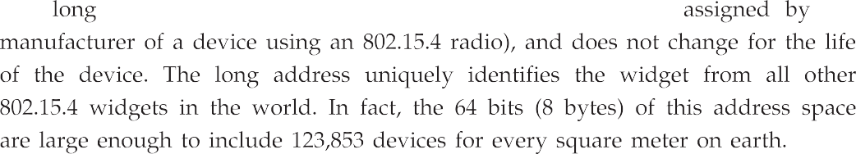

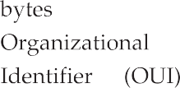 APS layer
APS Tx
APS Rx
NWK layer
NWK neighbor table
NWK Tx
NWK Rx
NWK routing table
MAC Tx
MAC Rx
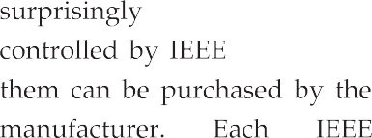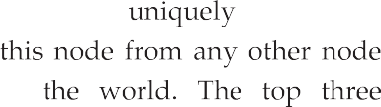

MAC layer
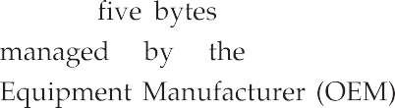

Frame Dest control addr
16b 16b
Src addr
16b
Radius
Seq #
0/8b
Dest
Src
IEEE addr IEEE addr
8b
0/64b
0/64b
Multicast control
0/8b
Source route
Variable
Payload
Frame type
2b
Protocol Discover Multicast
version
4b
route
2b
flag
1b
Security
Source route
1b
Dest
Src
IEEE addr IEEE addr
Resvd
1b
1b
1b
3b

- Data
- Command
10 or 11 Reserved
- No discovery
- If no route, discover 11 Force discovery

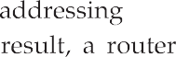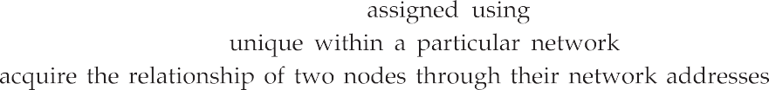

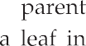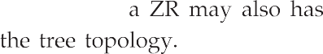 ZigBee coordinator ZigBee router
ZED

n0

n1 n2 n3

Depth 0

Depth 1

Depth 2
:
Depth n Depth n+1
Depth n+2

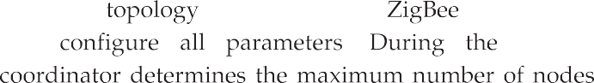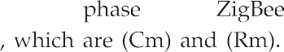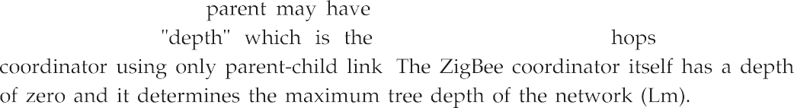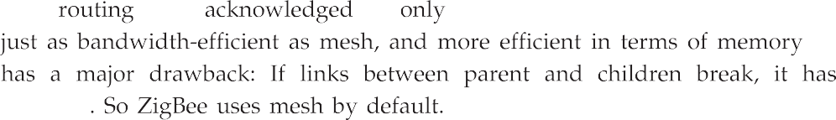

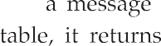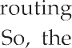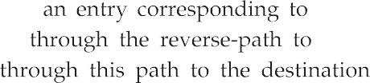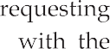
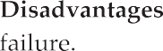
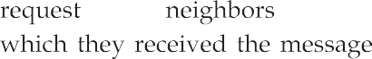

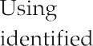

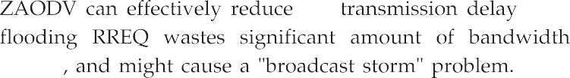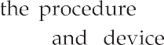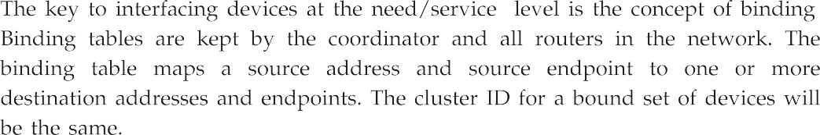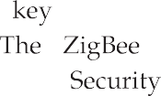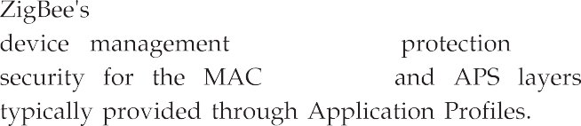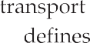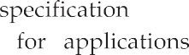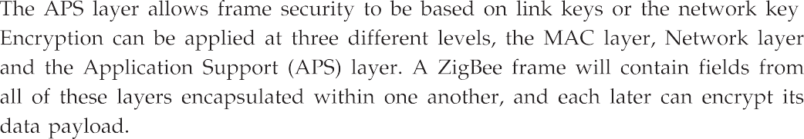

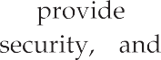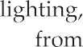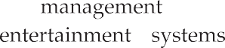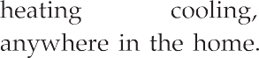
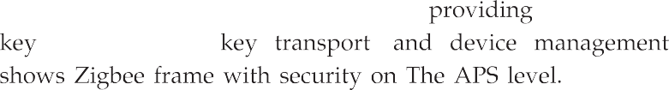

Application of security suite adds auxiliary header and also an integrity code
SYNC
PHY MAC NWK APS Auxiliary HDR HDR HDR HDR HDR
Encrypted APS payload
MIC
All of the above APS frame is integrity-protected

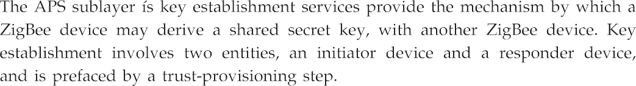
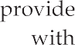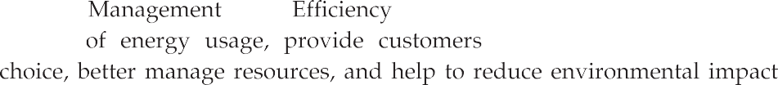

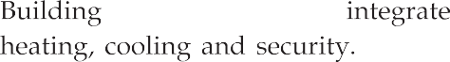

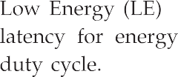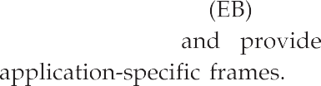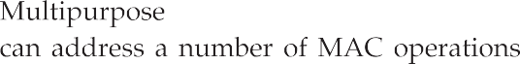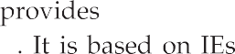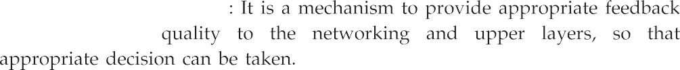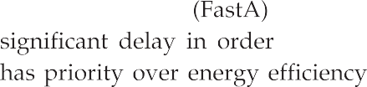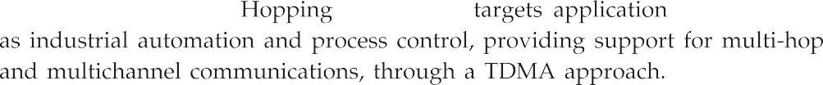
Frame control (2B)
Sequence Addressing number fields
(4 - 20B)
Auxiliary security header
Information elements
Frame payload
(1B)
Frame check sequence (2/4B0)
MAC header
MAC Payload MAC
Preamble
Start of frame delimiter
PHY header
PHY service data unit (PSDU)

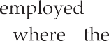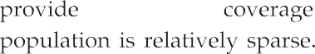
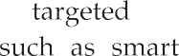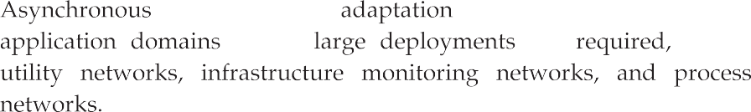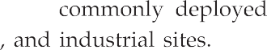
802.15.4g/e
Header
Security header
Payload (Encrypted)
Message integrity code

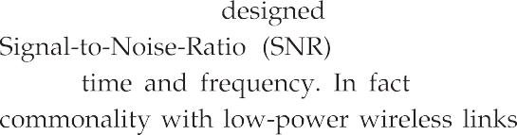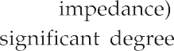
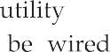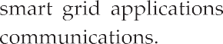

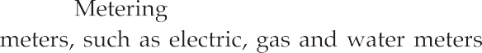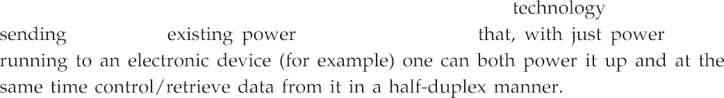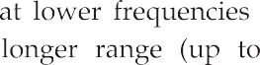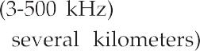

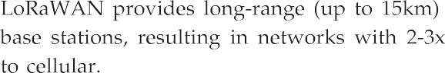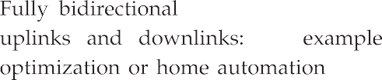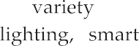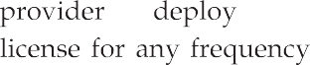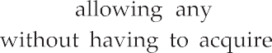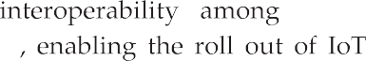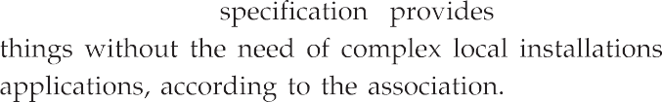
3
2
1
0/2
0/2/8
0/2
0/2/8 0/5/6/10/14 Variable Variable
2
Segment control
Frame Sequence Destination Destination
number
number
PAN
identifier
address
Source PAN
identifier
Source address
Auxiliary security header
Information elements
Frame payload
Frame check sequence

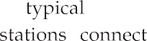
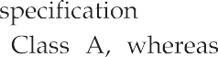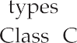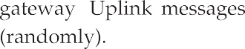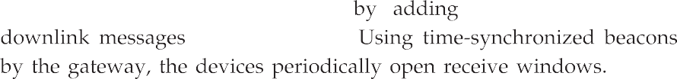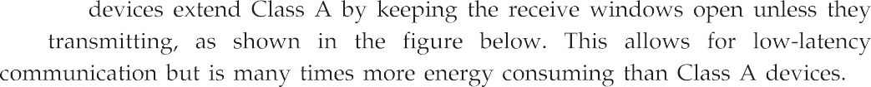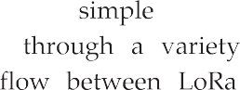
Applications
CoAP
MQTT IPv6/6LoWPAN
Raw
Others
LoRaWAN MAC
LoRa PHY Modulation
868 MHz
915 MHz
Other regional bands

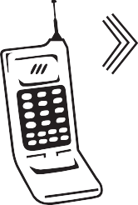
LoRaWAN Server Data

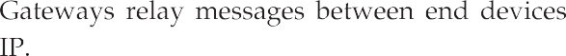
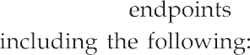

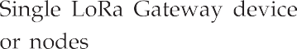
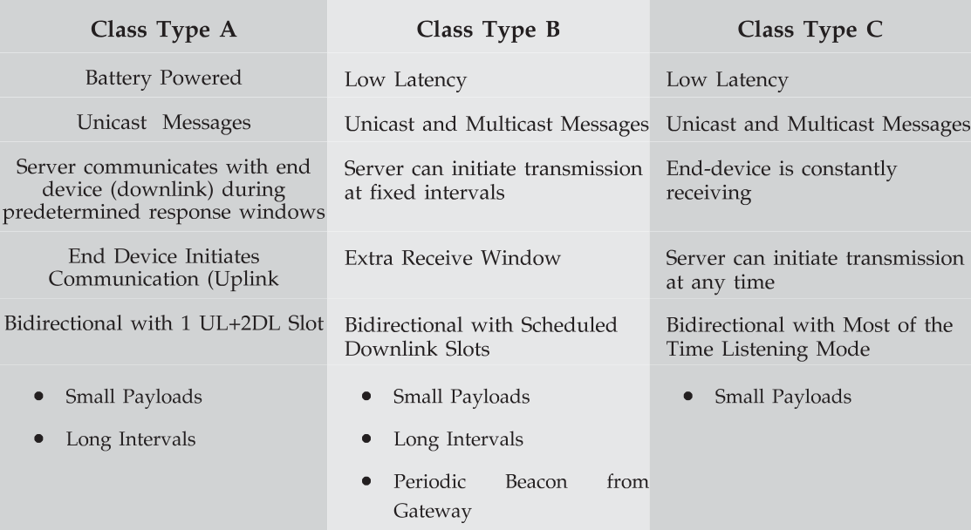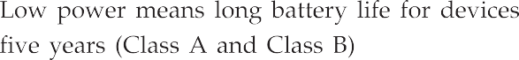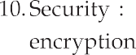

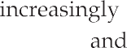

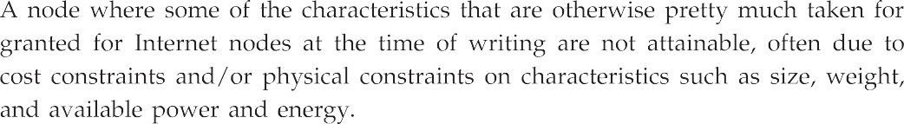
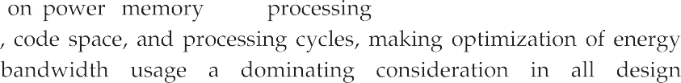

Wired/Wireless
DLL layer

Physical layer
Including 802.14.4g,802.15.4e
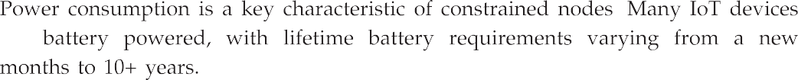
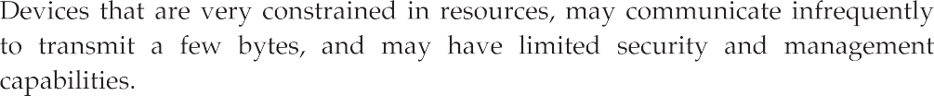
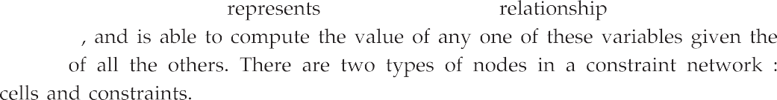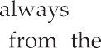
TCP/UDP

IPv4/IPv6
Transport layer

Network layer
Adaptation layer

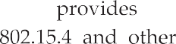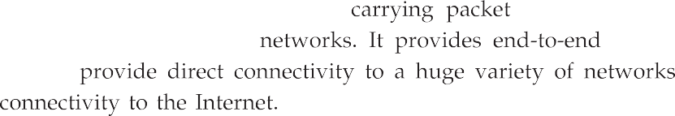
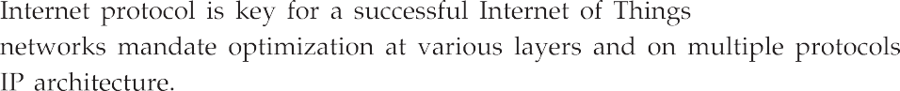
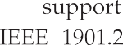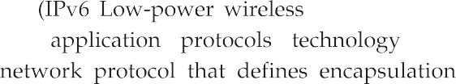

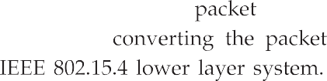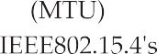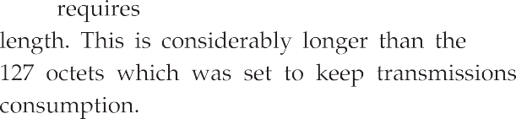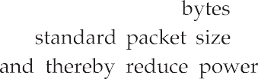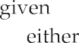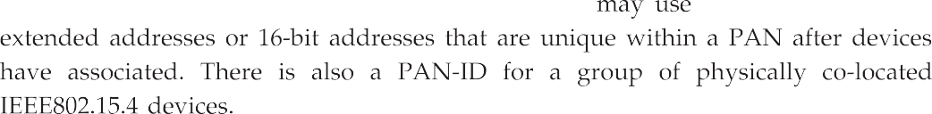

IP Protocol stack

Application
Application protocols UDP ICMP
IPv6

LoWPAN IEEE 802.15.4 MAC
IEEE 802.15.4 PHY
HTTP
RTP
TCP UDP ICMP IP
Ethernet MAC

Ethernet PHY

Transport Network Data link Physical

6LoWPAN protocol stack

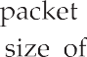
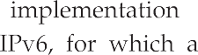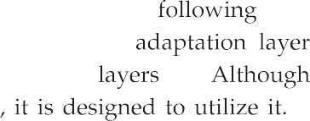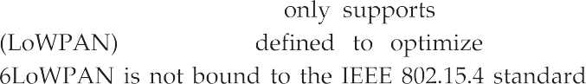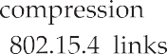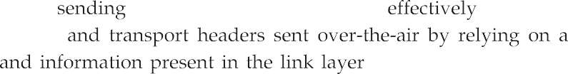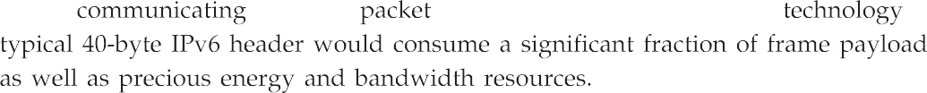
802.15.4
Header
IPv6 Header compression
IPv6 Payload
802.15.4
Header
Fragment header
IPv6 Header compression
IPv6 Payload
802.15.4
Header
Mesh addressing header
Fragment header
IPv6 Header compression
IPv6 Payload

IEEE 802.15.4 Frame (127 B)
21 B 1 B 40 B
MAC L IPv6
8 B
UDP
53 B
Payload
4B
FCS

Full UDP/IPv6 (64 - bit addressing)

IEEE 802.15.4 Frame (127 B)
9B 2B 4B 108 B 4B

MAC
L UDP
Payload
FCS

Dispatch and LOWPAN_IHC
LOWPAN NHC
Src
Dst
UDP checksum

Minimal UDP / 6LoWPAN (16- bit addressing)
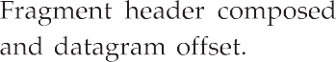
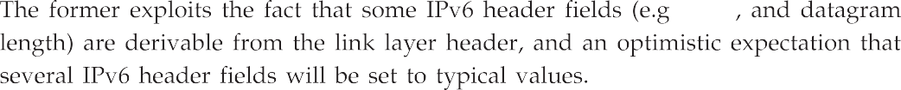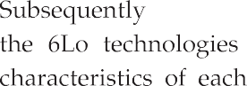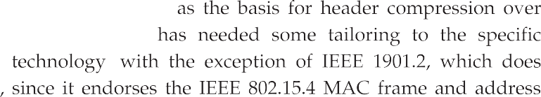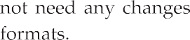
802.15.4
Header
6LoWPAN
fragmentation header
Datagram Datagram size tag
Datagram offset
FCS

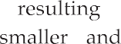
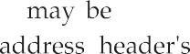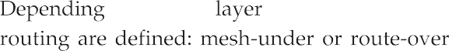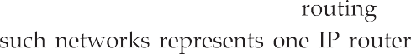

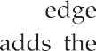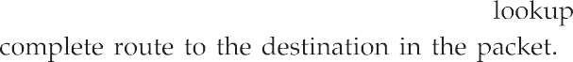
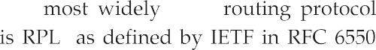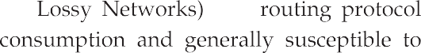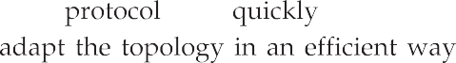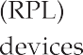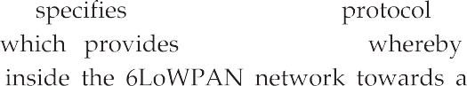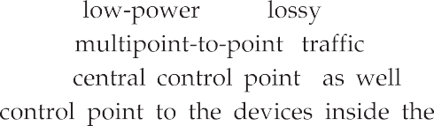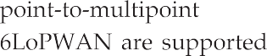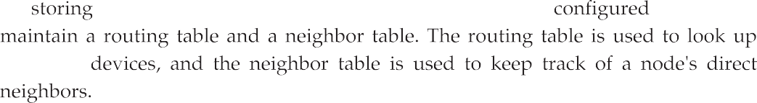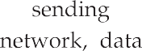

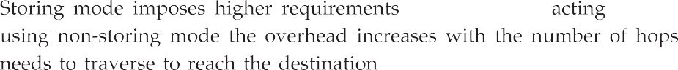

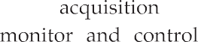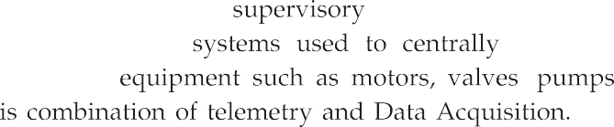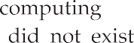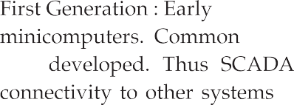

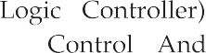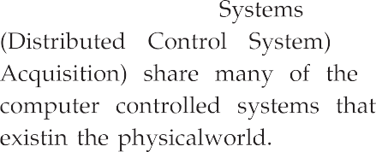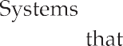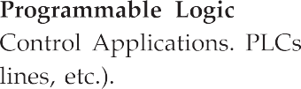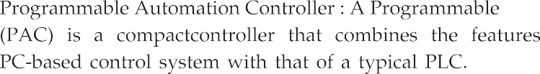

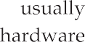
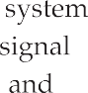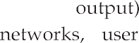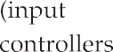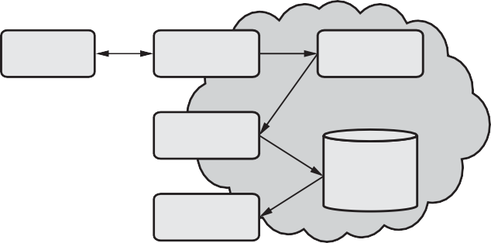
Process plant
Control system
OPC
server
Network (LAN)
Datalogging system
(Data engine)
Alarm system
SQL
database
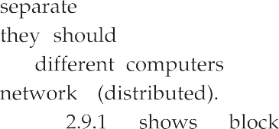

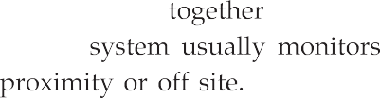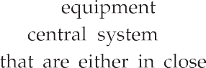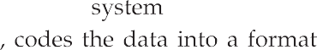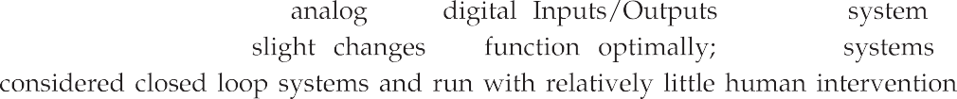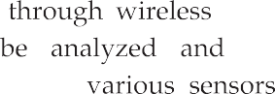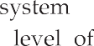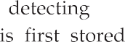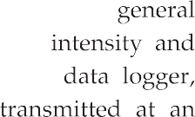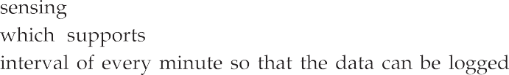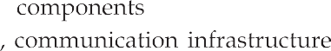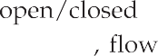

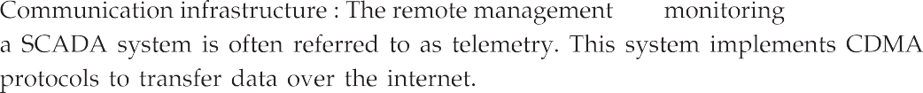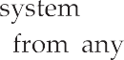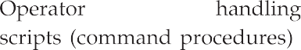
Operating system (Linux, Symbian, WinCE, QNX)
Application layer
Information Visualization SCADA Remote monitoring and systems applications packages diagnostic
System Safety Modeling and Web and server configurator applications simulations based applications
Device management
Service and application manager
Security management
Middleware
JAVA based applications
Human machine interface Mobility, Connectivity, Profile,
Content management
Control methods
Network connectivity and protocols Protocol stack
Test and measurements solutions
Motion and drives control solutions
Device driver
Industrial and control solutions
Hardware

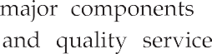
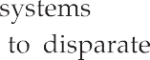

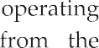
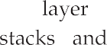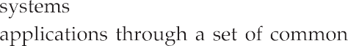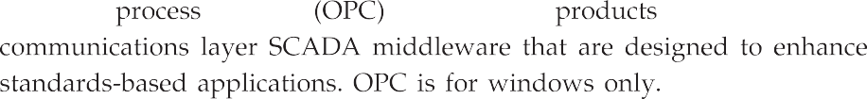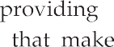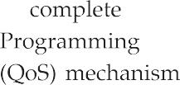

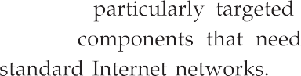
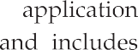
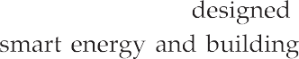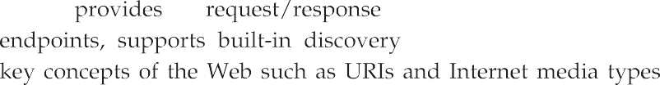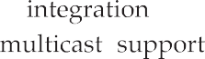

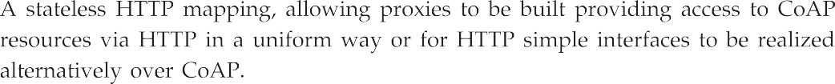
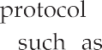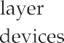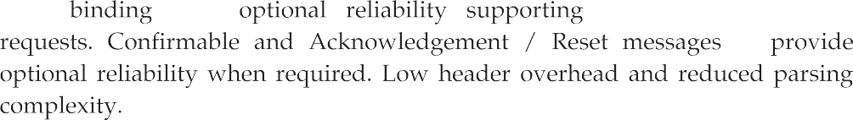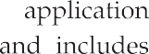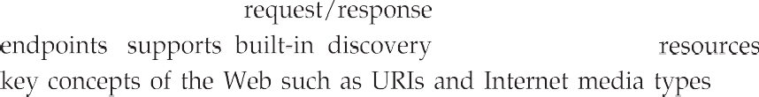

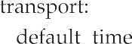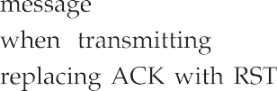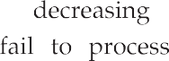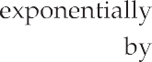

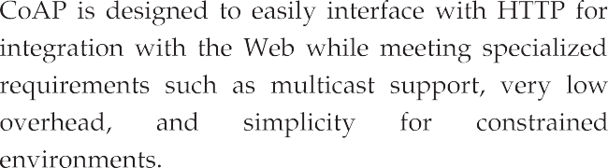
CoAP
Request/ Response

Message
UDP 6LoWPAN

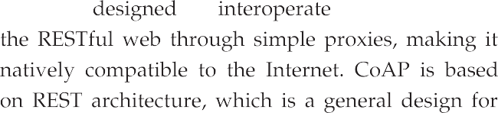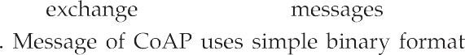

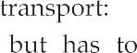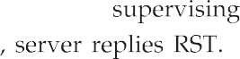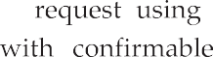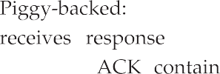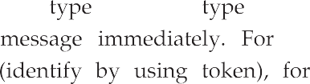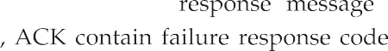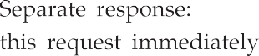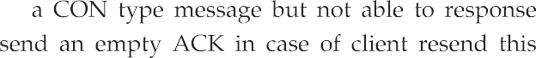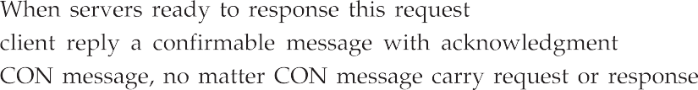

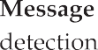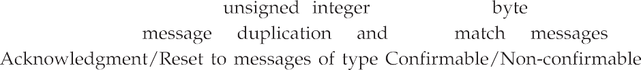

1 byte 1 byte 2 bytes TKL bytes Variable 1 byte Variable
V T TKL Code Message ID
Token Options 0xFF Payload (if any) (if any) (if payload) (if any)
2 2 4 bits

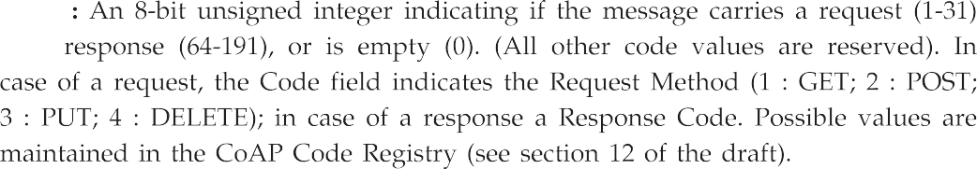

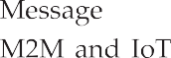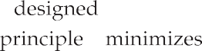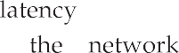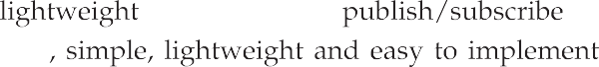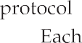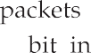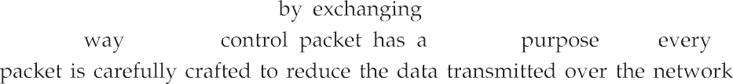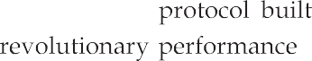

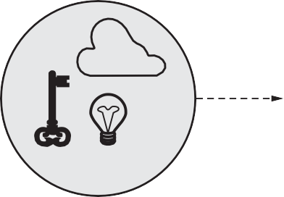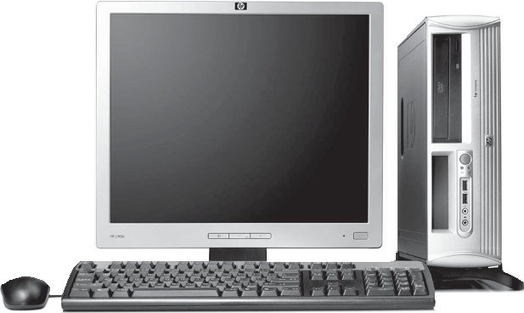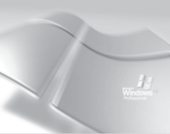
Message
Subscriber
Message
MQTT
Broker
hp
Message
Publisher
Subscriber

